Parte I

2

2.1.

x = [1018.4 1309.8 1580.8 1989.6 2315.5 2446.5 3467.2 4469.1 5030.6 5113.2 5611.6];

y = [-27 -7 -23 -34 -69 -138 -104 -91 -53 -120 -115];

plot(x,y,"\*")

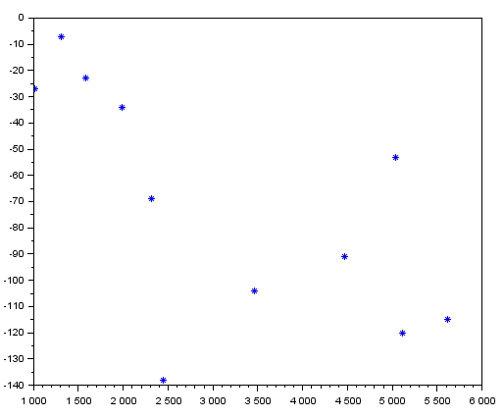

2.6.

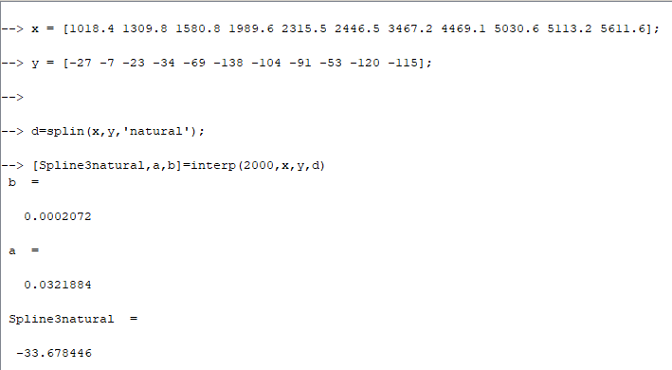

Parte II

3

3.1.

y = [-91 -34 -7 -23 -69 -138 -104 -53 -120 -115 -27 ];

x = [4469.1 1989.6 1309.8 1580.8 2315.5 2446.5 3467.2 5030.6 513.2 5611.6 1018.4];

[m,b]=reglin(x,y)